Computer Graphics Tutorial
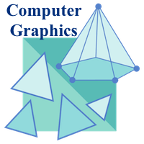
It is difficult to display an image of any size on the computer screen. This method is simplified by using Computer graphics. Graphics on the computer are produced by using various algorithms and techniques. This tutorial describes how a rich visual experience is provided to the user by explaining how all these processed by the computer.

Introduction of Computer Graphics
Computer Graphics involves technology to access. The Process transforms and presents information in a visual form. The role of computer graphics insensible. In today life, computer graphics has now become a common element in user interfaces, T.V. commercial motion pictures.
Computer Graphics is the creation of pictures with the help of a computer. The end product of the computer graphics is a picture it may be a business graph, drawing, and engineering.
In computer graphics, two or three-dimensional pictures can be created that are used for research. Many hardware devices algorithm has been developing for improving the speed of picture generation with the passes of time. It includes the creation storage of models and image of objects. These models for various fields like engineering, mathematical and so on.
Today computer graphics is entirely different from the earlier one. It is not possible. It is an interactive user can control the structure of an object of various input devices.

Definition of Computer Graphics:
It is the use of computers to create and manipulate pictures on a display device. It comprises of software techniques to create, store, modify, represents pictures.

Why computer graphics used?
Suppose a shoe manufacturing company want to show the sale of shoes for five years. For this vast amount of information is to store. So a lot of time and memory will be needed. This method will be tough to understand by a common man. In this situation graphics is a better alternative. Graphics tools are charts and graphs. Using graphs, data can be represented in pictorial form. A picture can be understood easily just with a single look.
Interactive computer graphics work using the concept of two-way communication between computer users. The computer will receive signals from the input device, and the picture is modified accordingly. Picture will be changed quickly when we apply command.
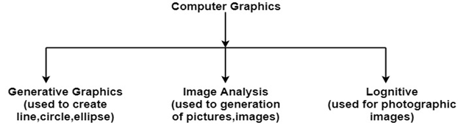

Computer Graphics Tutorial Index

Computer Graphics Tutorial
- Computer Graphics Tutorial
- Application of Computer Graphics

- Interactive and Passive Graphics
Graphic Systems
- Display Processor
- Cathode Ray Tube (CRT)
- Random Scan vs Raster Scan
- Color CRT Monitors
- Direct View Storage Tubes
- Flat Panel Display
Input-Output Devices
- Input Devices
- Trackball
- Light Pen
- Image Scanner
- Output Devices
- Plotters
Scan Conversion a line
- Scan Conversion Definition
- Scan Converting a Point
- Scan Converting a Straight Line
- DDA Algorithm
- Bresenham's Line Algorithm
Scan Conversion Circle
- Defining a Circle
- Defining a Circle using Polynomial Method
- Defining a Circle using Polar Coordinates Method
- Bresenham's Circle Algorithm
- Midpoint Circle Algorithm
Scan Converting Ellipse
- Scan converting a Ellipse
- Polynomial Method
- Trignometric Method
- Midpoint Ellipse Algorithm
Filled Area Primitives
- Boundary Fill Algorithm
- Flood Fill Algorithm
- Scan Line Polygon Fill Algorithm
2D Transformations
- Introduction of Transformation
- Translation
- Scaling
- Rotation
- Reflection
- Shearing
- Matrix Representation
- Homogeneous Coordinates
- Composite Transformation
- Pivot Point Rotation
2D-Viewing
- Window
- Window to Viewport Co-ordinate Transformation
- Zooming
- Panning
Clipping Techniques
- Clipping
- Point Clipping
- Line Clipping
- Midpoint Subdivision Algorithm
- Text Clipping
- Polygon
- Sutherland-Hodgeman Polygon Clipping
- Weiler-Atherton Polygon Clipping
Pointing & Positioning
- Pointing & Positioning Techniques
- Elastic or Rubber Band Techniques
- Dragging
Shading
- Introduction of Shading
- Constant Intensity Shading
- Gouraud shading
- Phong Shading
Animation
- Animation
- Application Areas of Animation
- Animation Functions
3D Computer Graphics
- Three Dimensional Graphics
- Three Dimensional Transformations
- Scaling
- Rotation
- Rotation about Arbitrary Axis
- Inverse Transformations
- Reflection
- Shearing
Hidden Surfaces
- Hidden Surface Removal
- Back Face Removal Algorithm
- Z-Buffer Algorithm
- Painter's Algorithm
- Scan Line Algorithm
- Subdivision Algorithm
- 3D Modelling System
Projection
- Projection
- Perspective Projection
- Parallel Projection
Programs
- Computer Graphics Programs

Prerequisite
Good knowledge and understanding of the concepts of C programming language are necessary for learning the concepts of Computer graphics. Good understanding about basic mathematics allows us to better understand the concept of computer graphics.

Audience
This tutorial is helpful for the students who are interested in learning the use of graphics on the computer. The tutorial covers the basics of graphics and development of various visuals by the implementation of graphics in the computer.

Problems
We assure that you will not find any problem with this Computer Graphics Tutorial. But if there is any mistake, please post the problem in the contact form.

Application of Computer Graphics
1. Education and Training: Computer-generated model of the physical, financial and economic system is often used as educational aids. Model of physical systems, physiological system, population trends or equipment can help trainees to understand the operation of the system.
For some training applications, particular systems are designed. For example Flight Simulator.
Flight Simulator: It helps in giving training to the pilots of airplanes. These pilots spend much of their training not in a real aircraft but on the ground at the controls of a Flight Simulator.

Advantages:
- Fuel Saving
- Safety
- Ability to familiarize the training with a large number of the world's airports.
2. Use in Biology: Molecular biologist can display a picture of molecules and gain insight into their structure with the help of computer graphics.
3. Computer-Generated Maps: Town planners and transportation engineers can use computer-generated maps which display data useful to them in their planning work.
4. Architect: Architect can explore an alternative solution to design problems at an interactive graphics terminal. In this way, they can test many more solutions that would not be possible without the computer.
5. Presentation Graphics: Example of presentation Graphics are bar charts, line graphs, pie charts and other displays showing relationships between multiple parameters. Presentation Graphics is commonly used to summarize
- Financial Reports
- Statistical Reports
- Mathematical Reports
- Scientific Reports
- Economic Data for research reports
- Managerial Reports
- Consumer Information Bulletins
- And other types of reports
6. Computer Art: Computer Graphics are also used in the field of commercial arts. It is used to generate television and advertising commercial.
7. Entertainment: Computer Graphics are now commonly used in making motion pictures, music videos and television shows.
8. Visualization: It is used for visualization of scientists, engineers, medical personnel, business analysts for the study of a large amount of information.
9. Educational Software: Computer Graphics is used in the development of educational software for making computer-aided instruction.
10. Printing Technology: Computer Graphics is used for printing technology and textile design.

Example of Computer Graphics Packages:
- LOGO
- COREL DRAW
- AUTO CAD
- 3D STUDIO
- CORE
- GKS (Graphics Kernel System)
- PHIGS
- CAM (Computer Graphics Metafile)
- CGI (Computer Graphics Interface)

Raster-Scan Displays

P
palaksinghal9903

• Read
• Discuss
• Courses
• Video

Raster Scan Displays are most common type of graphics monitor which employs CRT. It is based on television technology. In raster scan system electron beam sweeps across the screen, from top to bottom covering one row at a time.A pattern of illuminated pattern of spots is created by turning beam intensity on and off as it moves across each row. A memory area called refresh buffer or frame buffer stores picture definition. This memory area holds intensity values for all screen points. Stored intensity values are restored from frame buffer and painted on screen taking one row at a time.Each screen point is referred to as pixels.
In raster scan systems refreshing is done at a rate of 60-80 frames per second. Refresh rates are also sometimes described in units of cycles per second / Hertz (Hz). At the end of each scan line, electron beam begins to display next scan line after returning to left side of screen. The return to the left of screen after refresh of each scan line is known as horizontal retrace of electron beam. At the end of each frame electron beam returns to top left corner and begins the next frame.
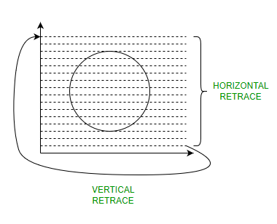
Raster-Scan Display Processor:
An important function of display process is to digitize a picture definition given in an application program into a set of pixel-intensity values for storage in refresh buffer. This process is referred to as scan conversion. The purpose of display processors is to relieve the CPU from graphics jobs.
Display processors can perform various other tasks like: creating different line styles, displaying color areas, etc. Typically display processors are utilized to interface input devices, such as mouse, joysticks.
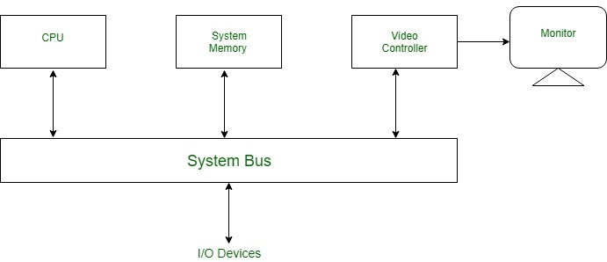
ADVANTAGES:
- Real life images with different shades can be displayed.
- Color range available is bigger than random scan display.
DISADVANTAGES:
- Resolution is lower than random scan display.
- More memory is required.
- Data about the intensities of all pixel has to be stored.

Random-Scan Display

P
palaksinghal9903

• Read
• Discuss
• Courses
• Video

In Random-Scan Display electron beam is directed only to the areas of screen where a picture has to be drawn. It is also called vector display, as it draws picture one line at time. It can draw and refresh component lines of a picture in any specified sequence. A Pen plotter is an example of random-scan device. The number of lines regulates refresh rate on random-scan displays. An area of memory called refresh display files stores picture definition as a set of line drawing commands. The system returns back to first-line command in the list, after all the drawing commands have been processed. High-quality vector systems can handle around 100, 00 short lines at this refresh rate. Faster refreshing can burn phosphor. To avoid this every refresh cycle is delayed to prevent refresh rate greater than 60 frames per second. Suppose we want to display a square ABCD on the screen. The commands will be:
- Draw a line from A to B
- Draw a line from B to C
- Draw a line from C to D
- Draw a line from D to A
Random-Scan Display Processors: Input in the form of an application program is stored in the system memory along with graphics package. Graphics package translates the graphic commands in application program into a display file stored in system memory. This display file is then accessed by the display processor to refresh the screen. The display processor cycles through each command in the display file program. Sometimes the display processor in a random-scan is referred as Display Processing Unit / Graphics Controller. The structure of a simple random scan is shown below:
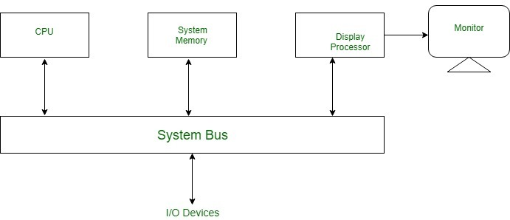
ADVANTAGES:
- Higher resolution as compared to raster scan display.
- Produces smooth line drawing.
- Less Memory required.
DISADVANTAGES:
- Realistic images with different shades cannot be drawn.
- Colour limitations.

Flat Panel Display:
The Flat-Panel display refers to a class of video devices that have reduced volume, weight and power requirement compare to CRT.
Example: Small T.V. monitor, calculator, pocket video games, laptop computers, an advertisement board in elevator.
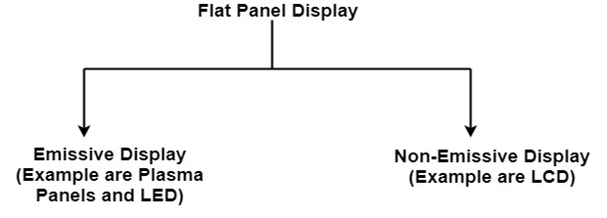
1. Emissive Display: The emissive displays are devices that convert electrical energy into light. Examples are Plasma Panel, thin film electroluminescent display and LED (Light Emitting Diodes).
2. Non-Emissive Display: The Non-Emissive displays use optical effects to convert sunlight or light from some other source into graphics patterns. Examples are LCD (Liquid Crystal Device).

Plasma Panel Display:
Plasma-Panels are also called as Gas-Discharge Display. It consists of an array of small lights. Lights are fluorescent in nature. The essential components of the plasma-panel display are:
- Cathode: It consists of fine wires. It delivers negative voltage to gas cells. The voltage is released along with the negative axis.
- Anode: It also consists of line wires. It delivers positive voltage. The voltage is supplied along positive axis.
- Fluorescent cells: It consists of small pockets of gas liquids when the voltage is applied to this liquid (neon gas) it emits light.
- Glass Plates: These plates act as capacitors. The voltage will be applied, the cell will glow continuously.
The gas will slow when there is a significant voltage difference between horizontal and vertical wires. The voltage level is kept between 90 volts to 120 volts. Plasma level does not require refreshing. Erasing is done by reducing the voltage to 90 volts.
Each cell of plasma has two states, so cell is said to be stable. Displayable point in plasma panel is made by the crossing of the horizontal and vertical grid. The resolution of the plasma panel can be up to 512 * 512 pixels.
Figure shows the state of cell in plasma panel display:
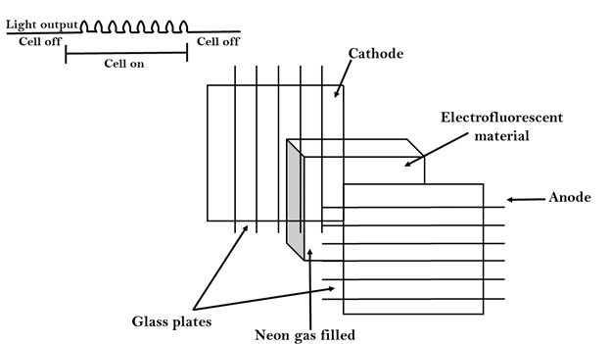

Advantage:
- High Resolution
- Large screen size is also possible.
- Less Volume
- Less weight
- Flicker Free Display

Disadvantage:
- Poor Resolution
- Wiring requirement anode and the cathode is complex.
- Its addressing is also complex.

LED (Light Emitting Diode):
In an LED, a matrix of diodes is organized to form the pixel positions in the display and picture definition is stored in a refresh buffer. Data is read from the refresh buffer and converted to voltage levels that are applied to the diodes to produce the light pattern in the display.

LCD (Liquid Crystal Display):
Liquid Crystal Displays are the devices that produce a picture by passing polarized light from the surroundings or from an internal light source through a liquid-crystal material that transmits the light.
LCD uses the liquid-crystal material between two glass plates; each plate is the right angle to each other between plates liquid is filled. One glass plate consists of rows of conductors arranged in vertical direction. Another glass plate is consisting of a row of conductors arranged in horizontal direction. The pixel position is determined by the intersection of the vertical & horizontal conductor. This position is an active part of the screen.
Liquid crystal display is temperature dependent. It is between zero to seventy degree Celsius. It is flat and requires very little power to operate.
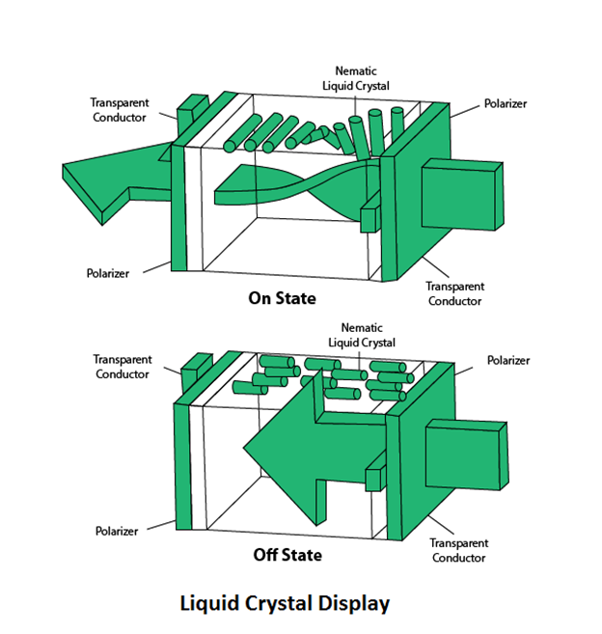

Advantage:
- Low power consumption.
- Small Size
- Low Cost

Disadvantage:
- LCDs are temperature-dependent (0-70°C)
- LCDs do not emit light; as a result, the image has very little contrast.
- LCDs have no color capability.
- The resolution is not as good as that of a CRT.

Look-Up Table:
Image representation is essentially the description of pixel colors. There are three primary colors: R (red), G (green) and B (blue). Each primary color can take on intensity levels produces a variety of colors. Using direct coding, we may allocate 3 bits for each pixel, with one bit for each primary color. The 3-bit representation allows each primary to vary independently between two intensity levels: 0 (off) or 1 (on). Hence each pixel can take on one of the eight colors.
Bit 1:r | Bit 2:g | Bit 3:b | Color name
0 | 0 | 0 | Black
0 | 0 | 1 | Blue
0 | 1 | 0 | Green
0 | 1 | 1 | Cyan
1 | 0 | 0 | Red
1 | 0 | 1 | Magenta
1 | 1 | 0 | Yellow
1 | 1 | 1 | White
A widely accepted industry standard uses 3 bytes, or 24 bytes, per pixel, with one byte for each primary color. The way, we allow each primary color to have 256 different intensity levels. Thus a pixel can take on a color from 256 x 256 x 256 or 16.7 million possible choices. The 24-bit format is commonly referred to as the actual color representation.
Lookup Table approach reduces the storage requirement. In this approach pixel values do not code colors directly. Alternatively, they are addresses or indices into a table of color values. The color of a particular pixel is determined by the color value in the table entry that the value of the pixel references. Figure shows a look-up table with 256 entries. The entries have addresses 0 through 255. Each entry contains a 24-bit RGB color value. Pixel values are now 1-byte. The color of a pixel whose value is i, where 0 <i<255, is persistence by the color value in the table entry whose address is i. It reduces the storage requirement of a 1000 x 1000 image to one million bytes plus 768 bytes for the color values in the look-up table.

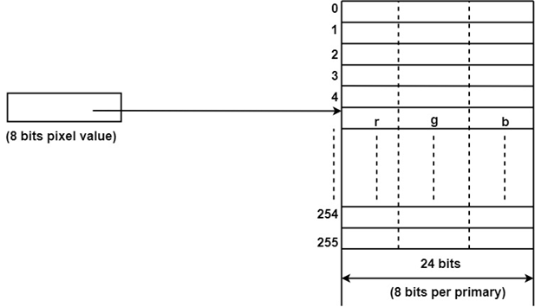 Plasma Display Panel in Computer Graphics

itskawal2000

• Read
• Discuss
• Courses

The first plasma displays that were available were technically televisions because they did not have TV tuners. The television tuner is the device that converts a television signal from a cable wire or any other means into a video image. Since the plasma displays lacked tuners, they were used as simple monitors that display a standard video signal. Recent developments have made inbuilt digital television tuners. Plasma Display Panel is an emissive display which means that the panel itself is the light source. In comparison to a transmissive display, where the light source is separate and light is passed through the panel to create an image, PDPs are extremely bright and light-tolerant flat panel display technology that utilizes a gas discharge principle thus also known as gas discharge display.
Plasma gives a big display screen length which degrees normally from 42” to 63”. It works properly in dimly lit rooms tremendous for looking movies, gives excessive assessment ratios, gorgeously saturated shades, and permits for extensive viewing angles each seat inside the residence is a tremendous one.
Because it can track fast-moving images without motion blur, plasma is ideal for watching action-packed sports or playing video games.
The working of the Plasma Display Panel is as follows:
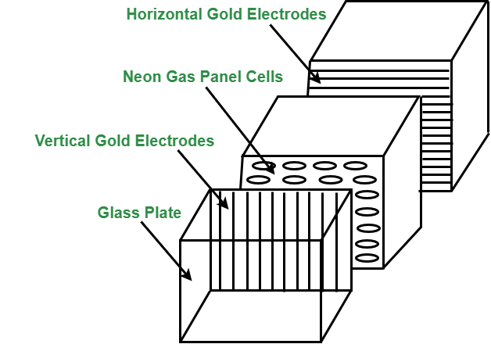
Plasma Panel Display
- Plasma Display Panel is composed of two parallel sheets of glass that enclose a mixture of discharge gases composed of helium, neon, and xenon.
- On the inner side of the glass, plates are Ribs, which help keep the glass plates parallel.
- Groups of electrodes sit at right angles between the panes forming rectangular compartments, or cells, between the glass sheets.
- Phosphorus is embedded within each cell that individually emits red, green, or blue light and collectively creates a single color pixel.
- Selectively applying voltages to the electrodes causes them to generate a discharge in the panel’s dielectric layer and on its protective surface. This generates ultraviolet light that excites the phosphors, stimulating them to emit light.
- The picture definition is stored in a Refresh Buffer, voltage is applied to refresh the pixel positions 60 times per second.
Advantages of Plasma Display Panel :
- Plasma Display Panel are thin lightweight and take up less space than other displays which makes them easy to install anywhere.
- Plasma Display Panel offers uniform brightness.
- They show images without distortion and avoid problems such as misregistered colors and lack of focus.
- They also resist interference from magnetic fields, are free from distortion and are viewable from a wide angle.
- Plasma Display Panel capable of producing deeper blacks allowing superior contrast ratio.
- It provides a wider viewing angle than those of LCD due to which images do not suffer from degradation at high angles.
- Plasma Display Panel are suitable for multimedia usage because they can display computer images as well as full-color, full-motion pictures.
Disadvantages of Plasma Display Panel :
- Plasma Display Panel uses more electricity, as an overlay than an LCD TV.
- Earlier generation Plasma Display Panel were more susceptible to screen burn-in and image retention, recent models have a pixel orbiter that moves the entire picture faster than is noticeable to the human eye, which reduces the effect of burn-in but does not prevent it.
- Earlier generation displays had phosphors that lost luminosity over time, resulting in the gradual decline of absolute.
- Due to the strong infrared emissions inherent in the technology standard Infrared repeater systems cannot be used in the viewing room. A more expensive “plasma compatible” sensor needs are used.

Image Formats


him0000

• Read
• Discuss
• Courses

Image Format describes how data related to the image will be stored. Data can be stored in compressed, Uncompressed, or vector format. Each format of the image has a different advantage and disadvantage. Image types such as TIFF are good for printing while JPG or PNG, are best for the web.
- TIFF(.tif, .tiff) Tagged Image File Format this format store image data without losing any data. It does not perform any compression on images, and a high-quality image is obtained but the size of the image is also large, which is good for printing, and professional printing.
- JPEG (.jpg, .jpeg) Joint Photographic Experts Group is a loss-prone (lossy) format in which data is lost to reduce the size of the image. Due to compression, some data is lost but that loss is very less. It is a very common format and is good for digital cameras, nonprofessional prints, E-Mail, Powerpoint, etc., making it ideal for web use.
- GIF (.gif) GIF or Graphics Interchange Format files are used for web graphics. They can be animated and are limited to only 256 colors, which can allow for transparency. GIF files are typically small in size and are portable.
- PNG (.png) PNG or Portable Network Graphics files are a lossless image format. It was designed to replace gif format as gif supported 256 colors unlike PNG which support 16 million colors.
- Bitmap (.bmp) Bit Map Image file is developed by Microsoft for windows. It is same as TIFF due to lossless, no compression property. Due to BMP being a proprietary format, it is generally recommended to use TIFF files.
- EPS (.eps) Encapsulated PostScript file is a common vector file type. EPS files can be opened in applications such as Adobe Illustrator or CorelDRAW.
- RAW Image Files (.raw, .cr2, .nef, .orf, .sr2) These Files are unprocessed and created by a camera or scanner. Many digital SLR cameras can shoot in RAW, whether it be a .raw, .cr2, or .nef. These images are the equivalent of a digital negative, meaning that they hold a lot of image information. These images need to be processed in an editor such as Adobe Photoshop or Lightroom. It saves metadata and is used for photography.
What is meant by image saved with transparency? Images saved with transparency look good on colored background whereas images without transparency will have a white background which will be visible on colored background.

Augmented Reality v/s Virtual Reality
In this article, we are going to discuss the comparison between augmented reality and virtual reality. Both of the terms are important, so first, we will see a description of them.
Hope it will be informative and knowledgeable to you in order to make you familiar with the terms Augmented Reality and Virtual Reality. So, without any delay, let's begin the topic.

Augmented Reality
The word "Augmented" means to add. It is created by using the technology by adding digital information to an image or something. Augmented reality is an important concept and impacts our lives deeply. It provides an improved version of reality as it uses different tools to make the environment existing and real. Augmented reality gives you an interactive experience of the real-world environment. It keeps you in your place and superimposes the technology in the form of text, sounds, and images.
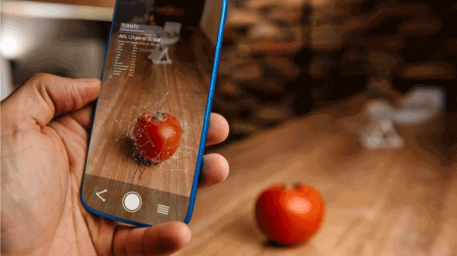
Augmented reality merges the physical world with computer-generated virtual elements. It is accessed using common equipment such as mobile phones. There are nearly uncountable possibilities with the Augmented Reality. With the smartphone's camera, AR adds the digital elements to a live view. It uses the smartphone's camera to present the real world's view in front of us and then put a layer of information that includes the text or images on the top of that view. Some of the examples of Augmented Reality are the Pokemon Go game, Snapchat lenses.
Now, let's see the benefits and limitations of augmented reality.

Advantages of Augmented Reality
The advantages of Augmented Reality are listed as follows -
- It increases accuracy.
- It offers innovation, continuous improvement, and individualized learning.
- It helps developers to build games that offer real experiences.
- It enhances the knowledge and information of the user.

Disadvantages of Augmented Reality
The limitations of Augmented Reality are listed as follows -
- Projects based on AR technology are expensive to implement and develop.
- Excessive use of augmented reality technology can lead to eye problems, obesity, etc.
- It can cause mental health issues
Now, let's see the description of Virtual reality.

Virtual Reality
It is a very important and interesting term. The terms 'Virtual' refers to something conceptual that does not have its physical existence, and the word 'reality refers to the state of being real. So, virtual reality means something that is almost real. It is defined as the creation of a simulated environment by using computer technology. Viewing virtual reality means viewing a completely different reality than the one in front of you. It can be artificial, like an animated scene or a place which is photographed and integrated in a virtual reality app. It enables us to move around and look in every direction - up, down, sideways, and behind, as we are present there actually.
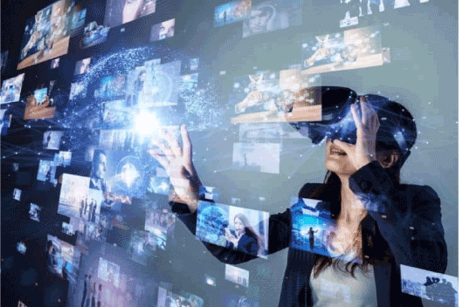
Virtual reality apps allow us to explore the places that we have never been to, such as the Mars surface, the top of Mt. Everest, areas deep under the sea, and many more things that we can imagine only. It uses three of our senses: hearing, touching, seeing, to trick the brain into thinking that we are at a different place.
Now, let's discuss the benefits and limitations of virtual reality.

Advantages of Virtual Reality
The benefits of virtual reality are listed as follows -
- It creates an interactive environment.
- It helps us to explore the world by creating a realistic world using computer technology.
- It makes education comfortable and easy.
- It allows users to do an experiment in an artificial environment.
- It increases the work capabilities.
- Virtual reality is helpful for medical students to do practice well. It will be helpful for patients, too, as it offers a safe environment to them by which a patient can come into contact with the things they fear.
- Virtual reality helps to measure the performance of sportsperson and analyze their techniques.

Disadvantages of Virtual Reality
The limitations of virtual reality are listed as follows -
- Using VR, people start ignoring the real world. They started living in the virtual world instead of dealing with the issues of the real world.
- Training in the virtual environment does not have the same result as training in the actual world.
- It is not guaranteed that a person has done a task well in the real world if he/she has performed that task well in the virtual world.

Augmented Reality v/s Virtual Reality
Now, let's see the comparison chart between Augmented reality and Virtual reality. Here, we are showing the comparison between both terms on the basis of some characteristics.
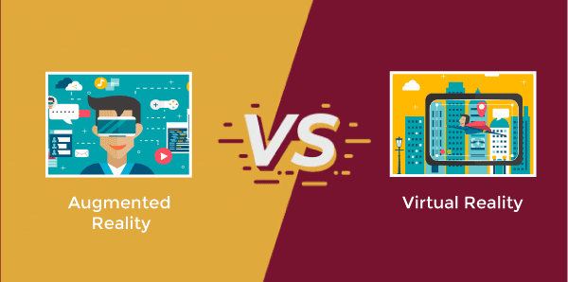
On the basis of | Augmented Reality | Virtual Reality
Involvement | In AR user is partially immersed with the real world, i.e. user is immersed with mix of real-world and virtual world. | In VR, the user is completely immersed in a virtual world.
Distinction | In augmented reality, it is easy to distinguish between both real-world and virtual world. | In Virtual reality, it is hard to distinguish between the virtual world and real world.
Devices used | In AR, there is a use of tablet, smartphones, or another mobile device. | In VR, there is a use of head-mounted display or glasses.
Reality and virtuality | Augmented reality is 75% real and 25% virtual. | Virtual reality is 75% virtual and 25% real.
Network data | Augmented reality requires upwards of 100Mbps bandwidth. | A virtual reality video with 720p requires a connection of atleast 50Mbps.
Revenue | The projected revenue share for augmented reality in 2020 is $120 million. | The projected revenue share for virtual reality in 2020 is $30 million.
Visual senses | In Augmented reality, a user always has a sense of presence in the real world. | Whereas, in virtual reality, the visual senses are under control of the system.

Types of Coordinate Systems
A coordinate system is used to determine each point uniquely in a plane. The study of the coordinate system led to innovations and research in the field of coordinate geometry. This study was initially developed by the French Philosopher and Mathematician Rene Descartes.
We know that a number line is a line that is used to represent the integers in both positive and negative directions from the origin. Rene Descartes invented the idea of placing two such lines perpendicular to each other on a plane and locating points on the plane by referring them to these lines. Though the two perpendicular lines can be in any direction, we usually choose one line on the vertical axis and the other perpendicular to it on the horizontal axis. In this article, we mainly discuss two types of coordinate systems.

Different Types of Coordinate Systems
There are mainly two types of coordinate systems, as listed below:

Cartesian Coordinate System
As stated above, it uses the concept of mutually perpendicular lines to denote the coordinate of a point. To locate the position of a point in a plane using two perpendicular lines, we use the Cartesian coordinate system. Points are represented in the form of coordinates (x, y) in two-dimension with respect to the x- and y- axes.
The x-coordinate of a point is its perpendicular distance from the y-axis measured along the x-axis, and it is known as abscissa. The y-coordinate of a point is its perpendicular distance from the x-axis measured along the y-axis, and it is known as ordinate. Read More.

Polar Coordinate System
Here, a point is chosen as the pole, and a ray from this point is taken as the polar axis. Basically, we have two parameters, namely angle and radius. The angle Ɵ with the polar axis has a single line through the pole measured anti-clockwise from the axis to the line.
The point will have a unique distance from the origin (r). Thus, a point in the polar coordinate system is represented as a pair of coordinates (r, Ɵ). The pole is represented by (0, Ɵ) for any value of Ɵ, where r = 0.
(r, Ɵ), (r, Ɵ + 2π) and (-r, Ɵ + π) are all polar coordinates for the same point.
The distance from the pole is called the radial coordinate, radial distance or simply radius and the angular coordinate, polar angle or azimuth.
Consider the figure below that depicts the relationship between polar and cartesian coordinates.
X = r cos Ɵ and y = r sin Ɵ
r = (x² + y²) ^{½} and tan Ɵ = (y/x)
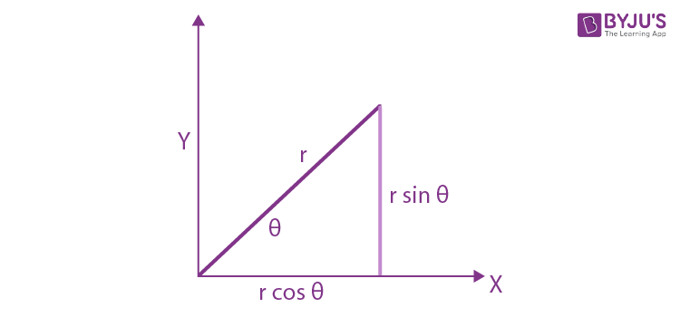
The polar equation of a curve consists of points of the form (r, Ɵ).
In the case of a circle, the general equation for a circle with a centre at (R, β) and
radius a is r² – 2rR cos(Ɵ – β) + R² = a².
Radial lines (those running through the pole) are represented by the equation: Ɵ = β.

Cartesian Formulae for the Plane
Distance between two points
The distance between two points of the plane (x₁, y₁) and (x₂, y₂) is given by
d = [(x₂ – x₁)² + (y₂ – y₁)² ]^{1/2}
In the case of a three-dimensional system, the distance formula between the points (x₁, y₁, z₁) and (x₂, y₂, z₂) is
d = [(x₂ – x₁)² + (y₂ – y₁)² + (z₂ – z₁)² ]^{1/2}
Representation of a vector
In two dimensions, the vector from the origin to the point with the Cartesian coordinates (x, y) can be written as r = xi + yj, where i = (1,0) and j = (0,1) are unit vectors in the direction of the x-axis and y-axis, respectively.
In the case of three dimensions, we will have r = xi + yj + zk, where k = (0,0,1) is the unit vector in the direction of the z-axis.

Also, Read:
Three-dimensional Geometry
Distance formula

Example Problems
Example 1: On graph paper, plot the point where Ajay has kept the lamp. He describes the situation as: the lamp is kept on a table which is taken as the reference. The lamp has a height of 2 units and is kept at the edge of the beginning end of the table.
Solution: As per the statement given in the question, the reference table is to be considered as the origin (0, 0). The position of the lamp, as stated above, clearly points out to be on the coordinate (0, 2). Thus, the point marked A is the position of the lamp with respect to the table reference marked as B. The following graph illustrates this.
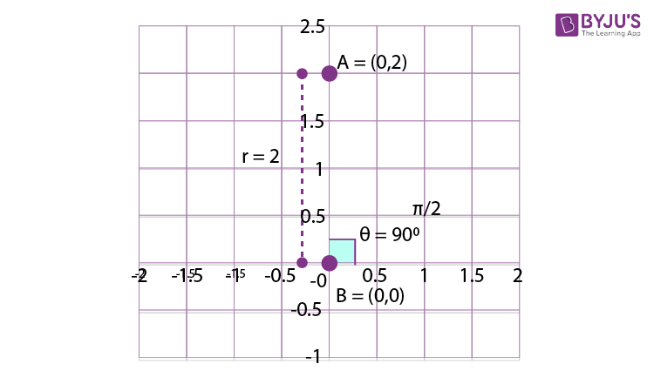

Example 2: Find the distance between the two points (4,5,6) and (9,8,2) in the x-y plane.
Solution: d = [(x₂ – x₁)² + (y₂ – y₁)² + (z₂ – z₁)² ]^{1/2}
Given: (x₁, y₁, z₁) = (4,5,6) and (x₂, y₂, z₂) = (9, 8, 2)
Therefore, x₂ – x₁ = 9 – 4 = 5.
Similarly, y₂ – y₁ = 8 – 5 = 3 and z₂ – z₁ = 2 – 6 = -4
Hence, d² = 5² + 3² + (-4)²
or, d = √50 units.
Example 3: The points
(�3,�), (2�3,2�), (�3,3�)
are the vertices of
A) An equilateral triangle
B) An isosceles triangle
C) A right-angled triangle
D) None of these
Solution:
Let
�(�3,�),�(2�3,2�) and �(�3,3�)
Then
��2=(�3−2�3)2+(�−2�)2=�23+�2=4�23
Similarly
��2=4�23a�� ��2=4�2
Hence, it is an isosceles triangle.
Example 4: If the point (x, y) is equidistant from the points (a + b, b – a) and (a – b, a + b), then
(A) ax + by = 0
(B) ax – by = 0
(C) bx + ay = 0
(D) bx – ay = 0
Solution:
{�−(�+�)}2+{�−(�−�)}2={�−(�−�)}2+{�−(�+�)}2=�2+(�+�)2−2�(�+�)+�2+(�−�)2−2�(�−�)=�2+(�−�)2−2�(�−�)+�2+(�+�)2−2�(�+�)
On simplification, we get bx – ay = 0
Trick: The locus will be the right bisector of the line joining the given points, therefore, the line must pass through the mid-points of the given point, i.e., (a, b). Obviously, the line given in option (d) passes through (a, b).

Polar Coordinates

8,534

Frequently Asked Questions
Q1

How do we represent a point in a Cartesian coordinate system?
A point can be represented as (x, y) in two-dimension with respect to the x- and y- axes. The x-coordinate is called the abscissa, and the y-coordinate is called the ordinate.
Q2

What is meant by a quadrant?
In the Cartesian system, the coordinate plane is divided into four regions by the intersection of the x-axis and the y-axis. These regions are called quadrants.
Q3

What is the Cartesian coordinate system used for?
We use a three-dimensional Cartesian coordinate system to represent vectors. The Cartesian coordinate system is also used to represent points, lines, planes etc.

